

**FPT ACADEMY INTERNATIONAL**

**FPT – APTECH COMPUTER EDUCATION**

Beauty care

|  |  |  |  |
| --- | --- | --- | --- |
| **Center Name** | | ACE-HCMC-2-FPT  Address: 590 Cach Mang Thang Tam, District 3, Ho Chi Minh City | |
| **Instructor** | | Ms. Pham Thi Lanh | |
| **Class** | | T1.2006.M1 | |
| **Group** | | 2 | |
| **Group members** | | **Name** | **Student ID** |
| Do Dinh Dai | Student1268268 |
| Dang Quoc Manh | Student1086350 |
|  |  |
| **Duration** | **Start date** | 5th September 2020 | |
| **End date** | 5th October 2020 | |

**This is to certify that**

**Ms./Ms.:**

Do Dinh Dai

Dang Quoc Manh

**has successfully designed & developed**

eProject: Beauty care

**Submitted by:**

Pham Thi Lanh

**Date of issue:**

**Authorized Signature:**

**TABLE OF CONTENTS**

ACKNOWLEDGEMENT 4

SYNOPSIS 4

PROBLEM STATEMENT 4

CUSTOMER'S REQUIREMENTS SPECIFICATIONS 5

SCOPE OF THE WORK (IN BRIEF) 6

ARCHITECTURE AND DESIGN OF THE SYSTEM 6

SITEMAP 8

MOCK OF THE WEBSITE 9

1. Homepage: 9

2. Products pages: 11

3. Contact us: 12

4. About us: 13

5. Gallery: 14

TASK SHEET REVIEW 1 15

WEBSITE DESCRIPTION 16

1. Homepage: 16

2. Product: 18

3. Contact us 19

3. About us 20

4. Gallery 21

5. New product 22

5. Account page 23

TASK SHEET REVIEW 2 24

# ACKNOWLEDGEMENT

It is often said that “Gratitude is the sign of noble souls”. That’s why we devote this chapter to express our deep gratitude towards those who have supported and guided us to accomplish this e-Project successfully.

First and foremost, we strongly appreciate the invaluable assistance that our beloved instructor – Ms. Pham Thi Lanh, has offered us. Whenever problems come up, she’ll always the one that we can count on for solutions. Anytime when our team chose a wrong way, Ms. Lanh gave us a pep talk to keep us back on the track. Therefore, once again, we truly value your dedication and guidance, Ms. Pham Thi Lanh.

Next, it would have been impossible to carry out and complete this project without the collaboration among our team members. Although we have gone through many obstacles during the project implementation, eventually we gained what we aimed at by our hard work, our strong commitment and of course.

Finally, thanks to this e-Project assignment, we had a golden opportunity to apply what we have learnt into reality and gain hands-on experience which is essential for our future career.

# SYNOPSIS

SIMPLON’s Beauty care centre is very big shop of cosmetics and accessories in the city. With the success of the shop, owner had opened few more shops in the different cities also. Simplon product is known for their quality of the service which they are providing since 1985. In order to advertize about the company and also to start online services the company wishes to make the website of the company.

For which they have approach you to design the website and requirement specification for the same is given below:

The website is to be developed for the Windows Platform using HTML5, JavaScript and Geolocation. The site should work well in all leading browsers including Chrome, IE, Firefox etc.

# PROBLEM STATEMENT

After reading the expectations from Simplon, our group has discussed about what should to be done to fulfil their requirements properly. We came to conclusion that in order to achieve the best result, we should deal with following queries:

1. How many products are included in the website?
2. How is each webpage designed to offer users the enjoyable experience?
3. How is search and cart function programed?
4. How do web users interact with the website?
5. Will the web run successfully on web browsers?

Additionally, the website will be built to run efficiently only on Windows platform. However, it still can be compatible on all leading web browsers such as Chrome, IE and Firefox. We make use of HTML5, Bootstrap, Jquery, and AngularJs to create a website that both runs smoothly and has a friendly UI.

# CUSTOMER'S REQUIREMENTS SPECIFICATIONS

The Web site is to be created based on the following requirements.

1. The Home Page should be created with proper sections, graphics and with a suitable logo.
2. The look and feel of the project must be made user friendly and uniformity in the color combination must be maintained.
3. About us, Contact Us (address and map) must be added. In the Contact Us page the website of all the shops location must be given.
4. All the categories of the products like HAIR, SKIN, MAKE-UP KITS, NAIL PAINTS, NAIL ARTS, JEWELLRY, WEDDING KITS, UPCOMING PRODUCTS & so on. For each product the cost must be mentioned in the list.
5. Feedback page must be added to take the valuable feedback from the users.
6. Contact Us, About Us.
7. Use GeoLocation API to show the address or location of SIMPLON’s Beauty care centre on the maps.
8. Gallery section can be included.
9. Navigation of the project must be made user friendly.
10. Customer must be allowed to place the order by selecting the product.

While placing the dummy order, the total cost of the order must be calculated.

1. **Client: SIMPLON’s Beauty care Information** website
2. **Business/Project Objective:**

Provide a website to displays the programs and services about shop such as : “Products”, “About us”, “Contact us”, “Gallery”, “Feedback”,...

Enable customer to see what event that they would like. Easier in interactive with us.

1. **Input to the system:**

* Inputs to the existing system.
* Outputs from the existing system.
* Process involved in the application.
* Expected delivery dates.
* List of deliverables.

1. **Hardware/ Software Requirements**

* **For webmaster**

**Hardware**

* Intel Pentium 4 processor or higher
* 1 Gigabytes of RAM or higher

**Software**

* Windows 7 OS or higher
* Visual Studio Code and Webstorm
* HTML5 and Javascript supporting web browsers such as IE, Chrome or Firefox
* **For web users**

**Hardware**

* Intel Pentium 4 processor or higher
* 512 Megabytes of RAM or higher

**Software**

* Windows XP OS or higher
* HTML5 and Javascript supporting web browsers such as IE, Chrome or Firefox

# SCOPE OF THE WORK (IN BRIEF)

After a long and detailed discussion, our group has decided to create a website contain the following webpages:

1. ***Homepage***: Display information about slideshow of promotion, slideshow list of products, review from customer.
2. ***Products***: Display information about the products. Customers can find the product they are looking for in the product category.
3. ***Contact us***: Customer can contact Simplon.
4. ***About us***: Display information about Simplon.
5. ***Gallery***: Display image gallery.

# ARCHITECTURE AND DESIGN OF THE SYSTE

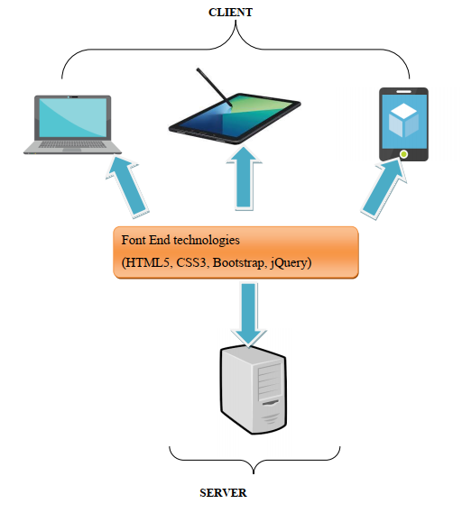

# SITEMAP

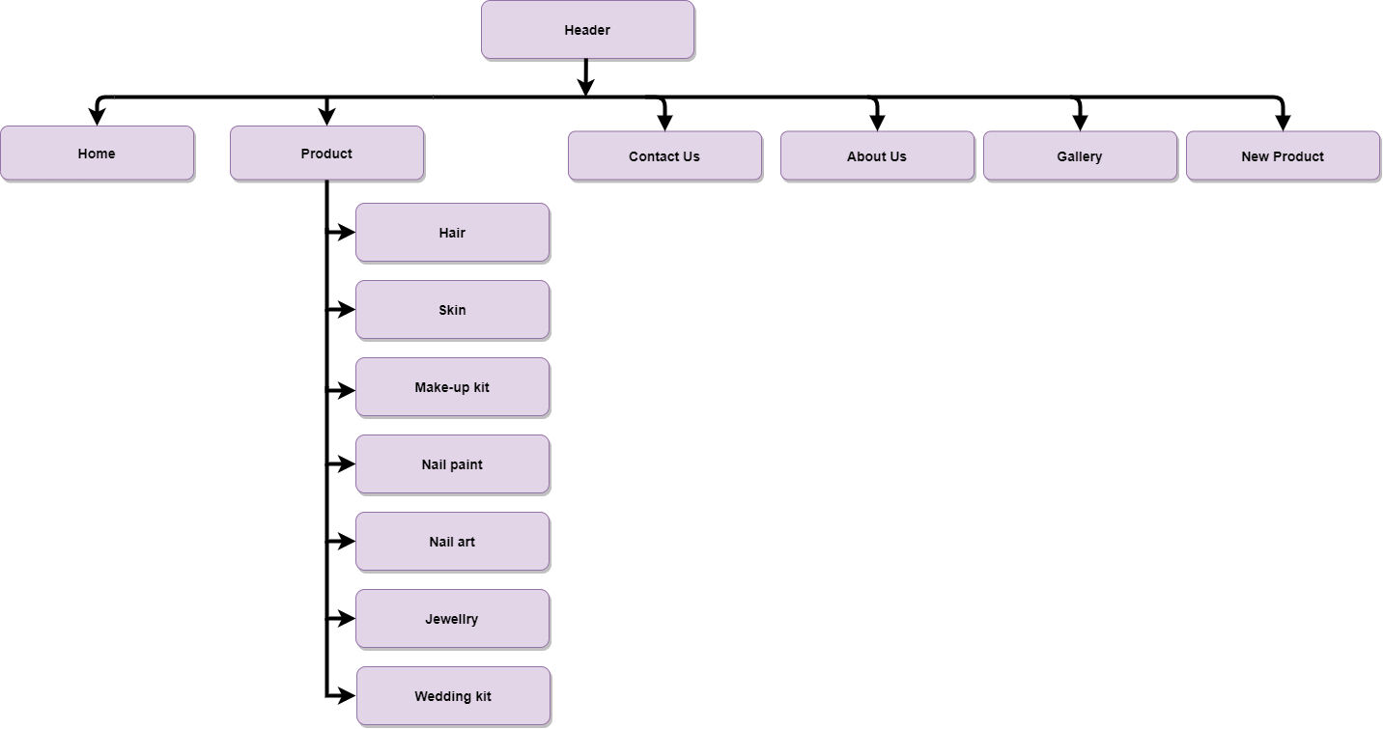

# MOCK OF THE WEBSITE

Here are our layouts which will show you how we brainstormed ideas for the Beauty care’s web pages. Because of being academic website, we tried to build them simple but useful and informative as much as possible.

The website is going to have several pages which include different information in the same main layout.

### 1. Homepage:

This layout below describes how we created our Homepage which contain three important parts:

-Page-header and Navigation bar:

Page-header must have Simplon’s Beauty care centre’s logo, account, cart and search bar is optional.

Navigation bar is one of the most crucial sections in the whole website which will indicate people how they interact with us. It provides some information like Homepage, Products, Contact us, About us, Gallery. Each section must have brief information.

-Content:

This part is customized belong to the title of the individual websites, especially Homepage with some descriptions about the Simplon’s Beauty care, some of the products, promotional products, new products,…

-Footer:

The final part of all our websites is definitely Footer which will reveal some convenient ways to contact the shop in different social channels like Email, Facebook, Twitter, Skype,...

|  |
| --- |
| **REVIEW**  **PRODUTS**  **FOOTER**  **SLIDESHOW LIST OF PRODUCTS**  **PICTURE SLIDESHOW**  **(PROMOTION)**  **NAVIGATION BAR**  **HEADER**  **(LOGO – ACOUNT-CREAT AN ACCOUNT)** |

### 2. Products pages:

|  |
| --- |
| **FOOTER**  **PRODUCTS**  **product**  **product**  **product**  **product**  **product**  **product**  **product**  **product**  **SLIDESHOW LIST OF PRODUCTS**  **NAVIGATION BAR**  **HEADER**  **(LOGO – ACOUNT-CREAT AN ACCOUNT)** |

### 3. Contact us:

|  |
| --- |
| **FOOTER**  **Name:**  **Phone:**  **Email:**  **Comment:**  **FORM CONTACT US**  **NAVIGATION BAR**  **HEADER**  **(LOGO – ACOUNT-CREAT AN ACCOUNT)** |

### 4. About us:

|  |
| --- |
| **Information about Simplon’s Beauty Care Centre like store near you, creator and more**  **FOOTER**  **FORM CONTACT US**  **NAVIGATION BAR**  **HEADER**  **(LOGO – ACOUNT-CREAT AN ACCOUNT)** |

### 5. Gallery:

|  |
| --- |
| **Image**  **Image**  **Image**  **Image**  **Image**  **Image**  **Image**  **Image**  **Gallery**  **FOOTER**  **NAVIGATION BAR**  **HEADER**  **(LOGO – ACOUNT-CREAT AN ACCOUNT)** |

# TASK SHEET REVIEW 1

|  |  |  |  |  |  |  |  |
| --- | --- | --- | --- | --- | --- | --- | --- |
| **Project Ref. No.:**  **eP/Advertisement** **Portal Management** **System/01** | | **Project Title:** | **Activity Plan** **Prepared** **By:** | **Date of Preparation of Activity Plan:** | | | |
| **Sr.No.** | **Task** | **Actual Start** **Date** | **Actual** **Days** | **Team** **Mate** **Names** | **Status** |
| 1 | Create layouts for website base on group discussion | Beauty Care | All members | 7/9/2020 | 1 |  | Completed |
| 2 | Draw layouts using Paint | 9/9/2020 | 1 |  | Completed |
| 3 | Write project report 1 | 11/09/2020 | 1 |  | Completed |
| 4 | Homepage design and coding (include navigation bar and footer | 14/09/2020 | 1 | All members | Completed |

|  |  |
| --- | --- |
| Date: | |
| Signature of Instructor  **Ms. Pham Thi Lanh** | Signature of Team Leader  **Do Dinh Dai** |

# WEBSITE DESCRIPTION

## 1. Homepage:

a) *Description*

- The overall website interface is designed in light pink tones, aimed at female customers. This webpage displays following information: Simplon introduction, product, contact us, about us, gallery, new product, sign in and create an account.

- Navigation bar: this menu bar allows user to navigate to every webpage of the whole website. For example, users need to click on product so the Product page will open. The same method is applied for other pages.

- Footer: The footer has the address of head office. Product menu bar for quick access. With quick links you can return to the main faster, improved user experience.

b) *Screenshot*

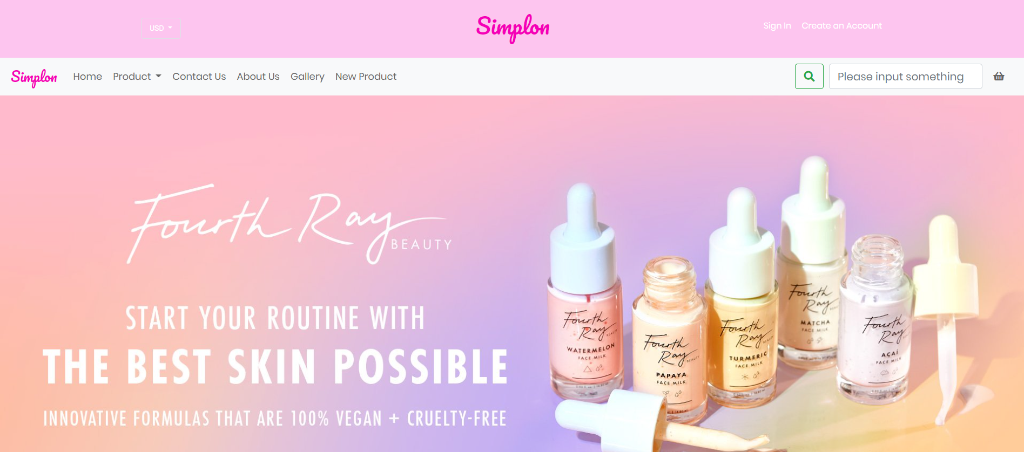 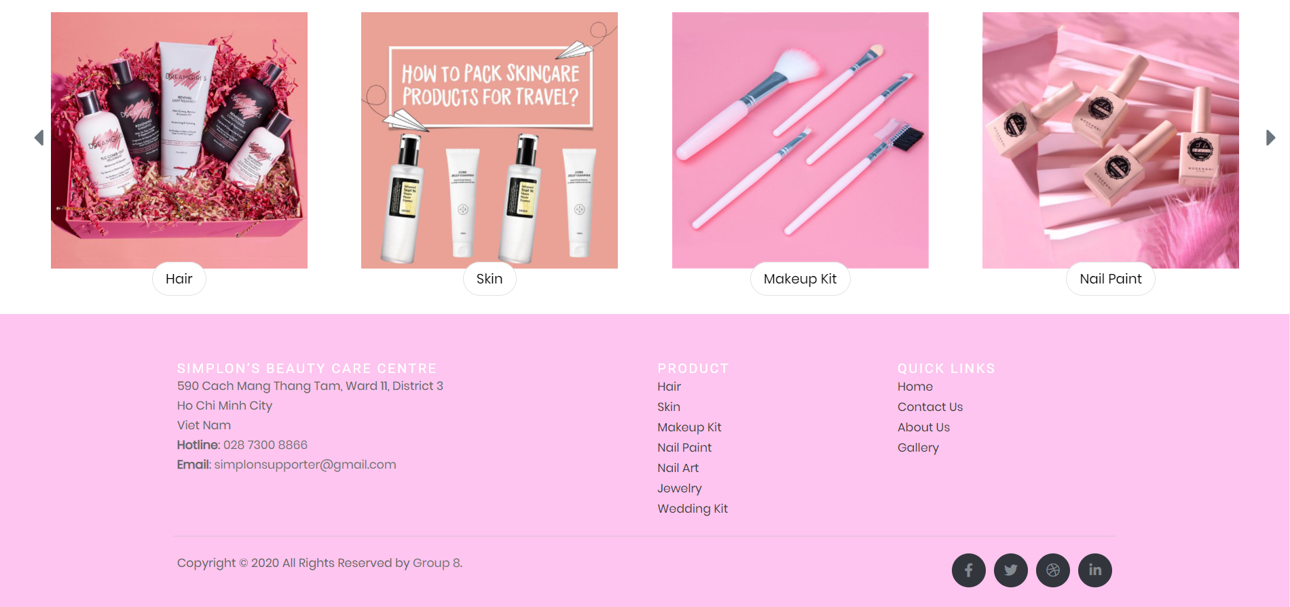

## 2. Product:

a. *Description*

This webpage displays from different brands. There are seven main product groups: hair, skin, makeup kit, nail paint, nail art, jewelry, wedding kit. When the user places the mouse pointer on the product three icons will appear as favorites, add to cart, and enlarge the image.

b. *Screenshot*

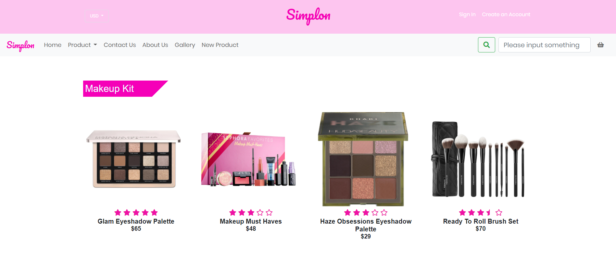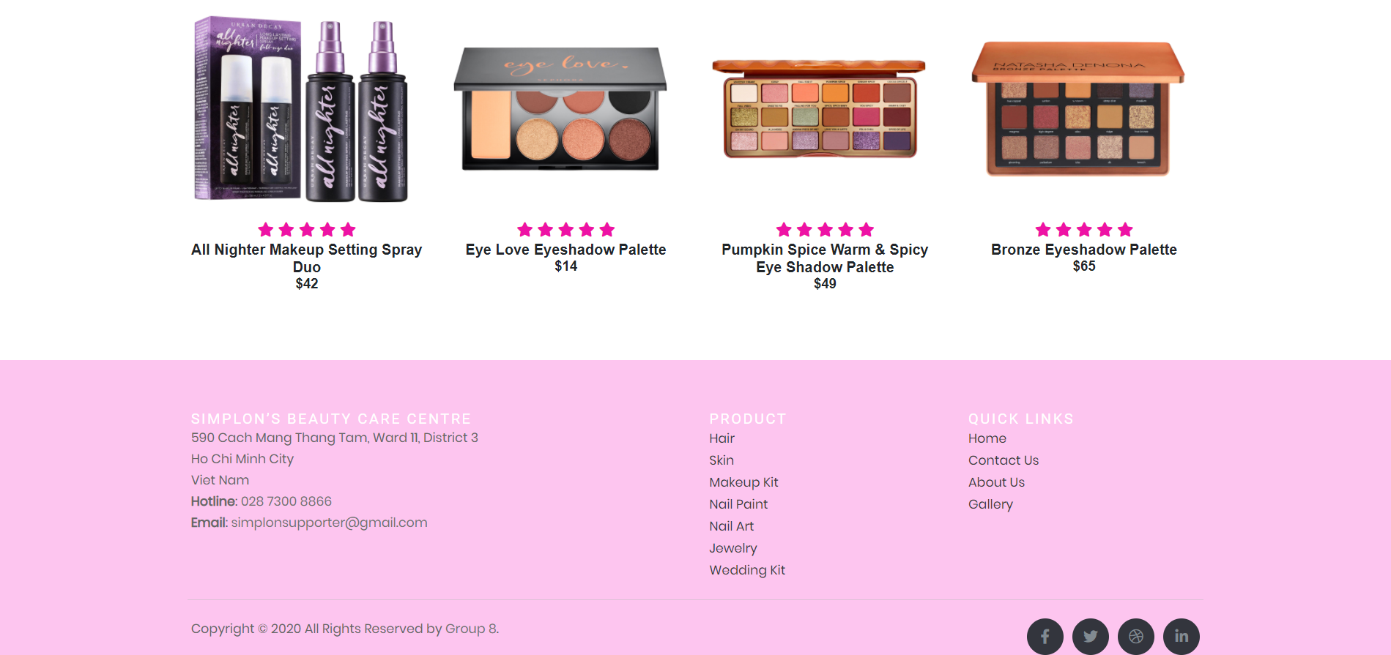

## 3. Contact us

a. *Description*

This page user can be contact with Simplon. Customers can leave information for us to contact. This page below will show you map to the hospital with Geolocation API and main contact information.

b. *Screenshot*

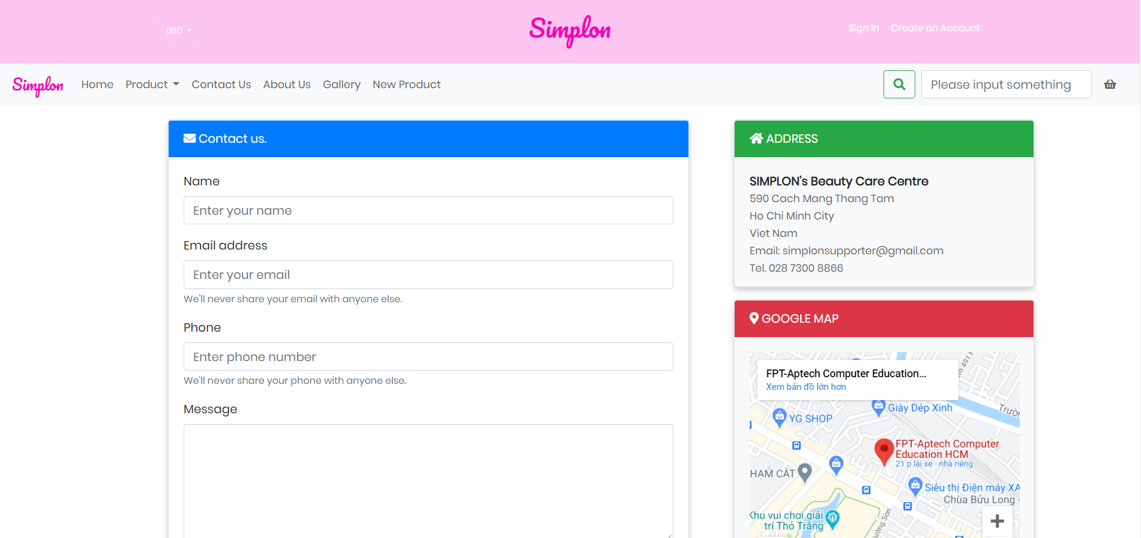 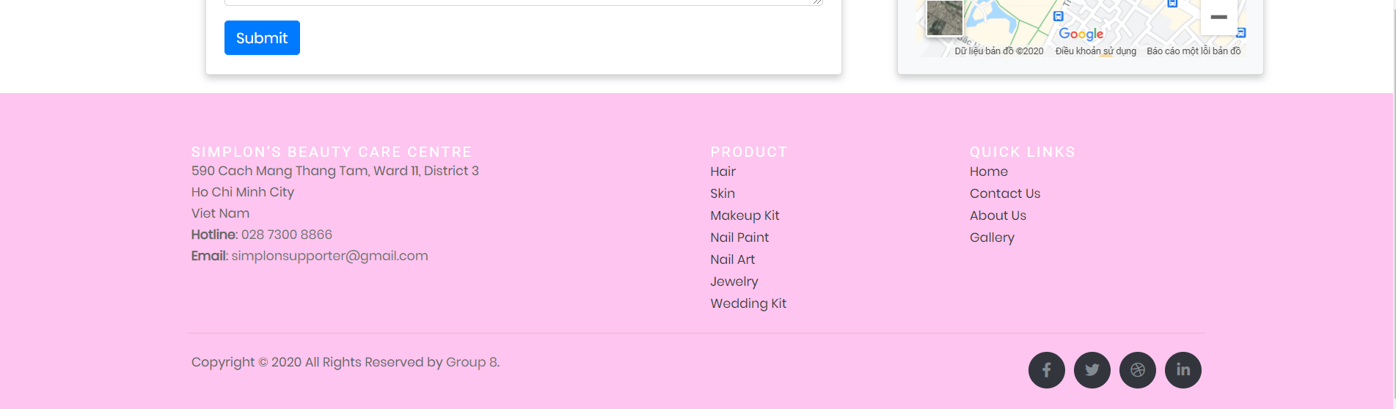

## 3. About us

a. *Description*

This page contains the following information: introduction about Simplon, and web creator.

b. *Screenshot*

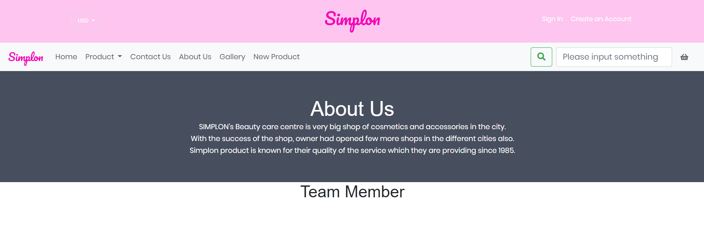 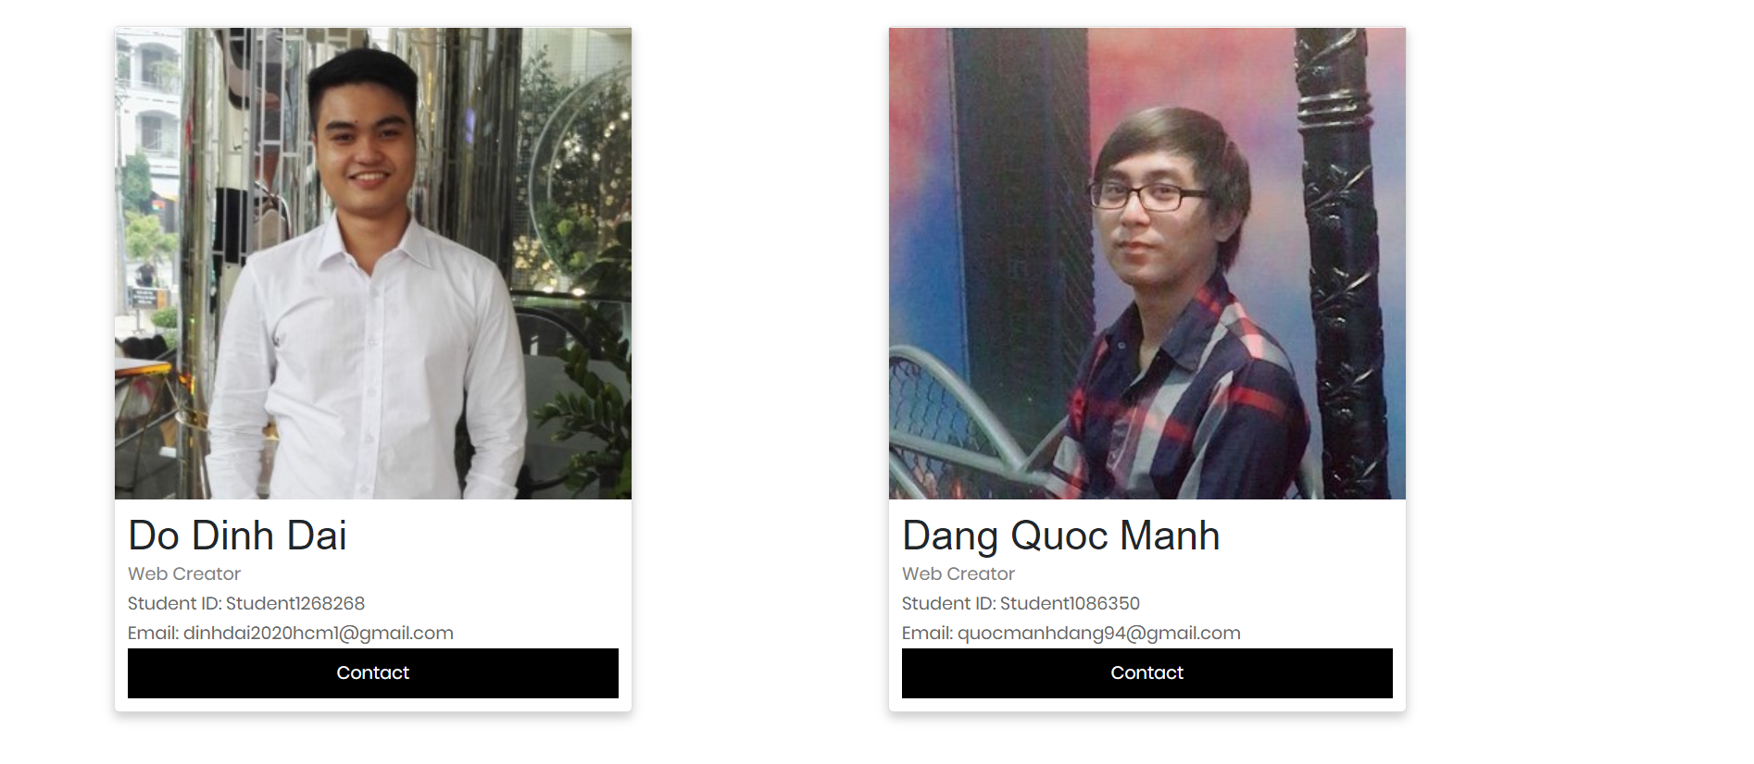 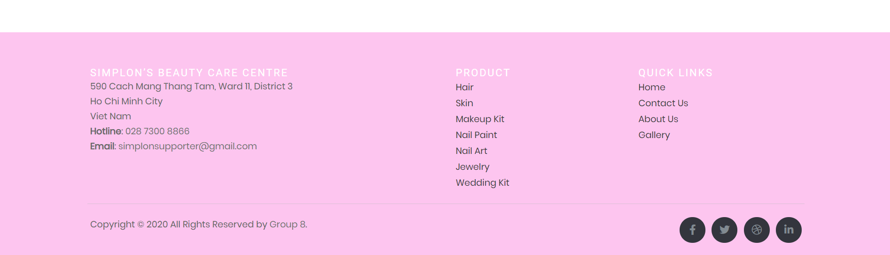

## 4. Gallery

a. *Description*

This page contains the following information: introduction about Simplon, and web creator.

b. *Screenshot*

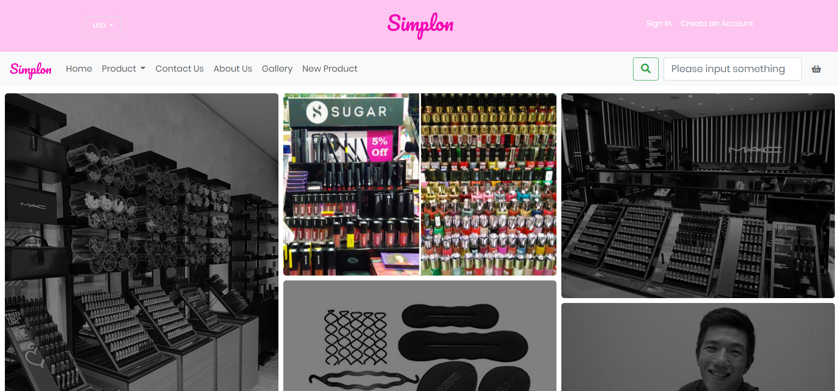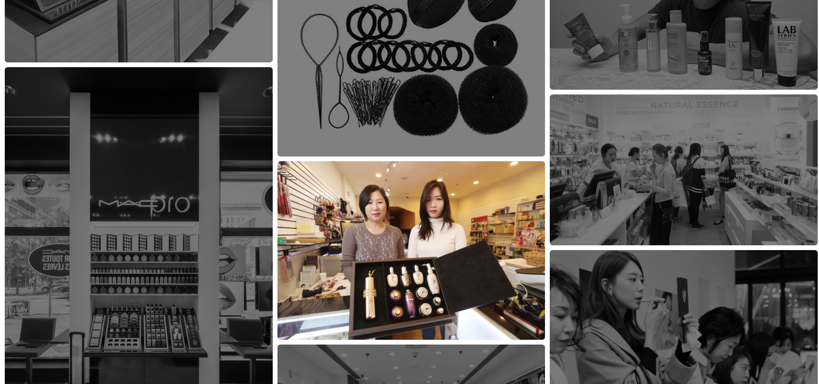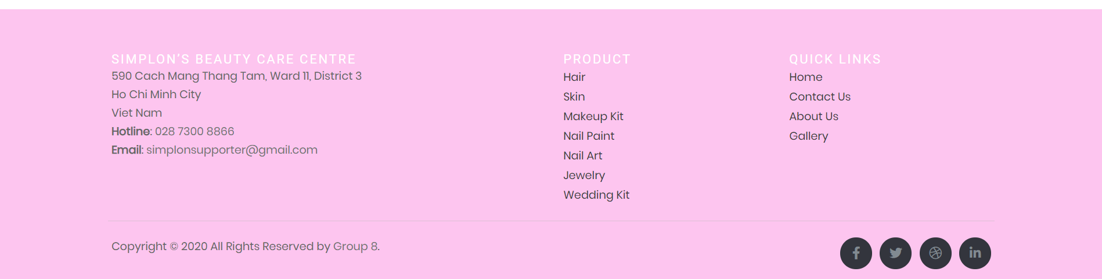

## 5. New product

a. *Description*

This page shows new products, similar functionality as page product.

b. *Screenshot*

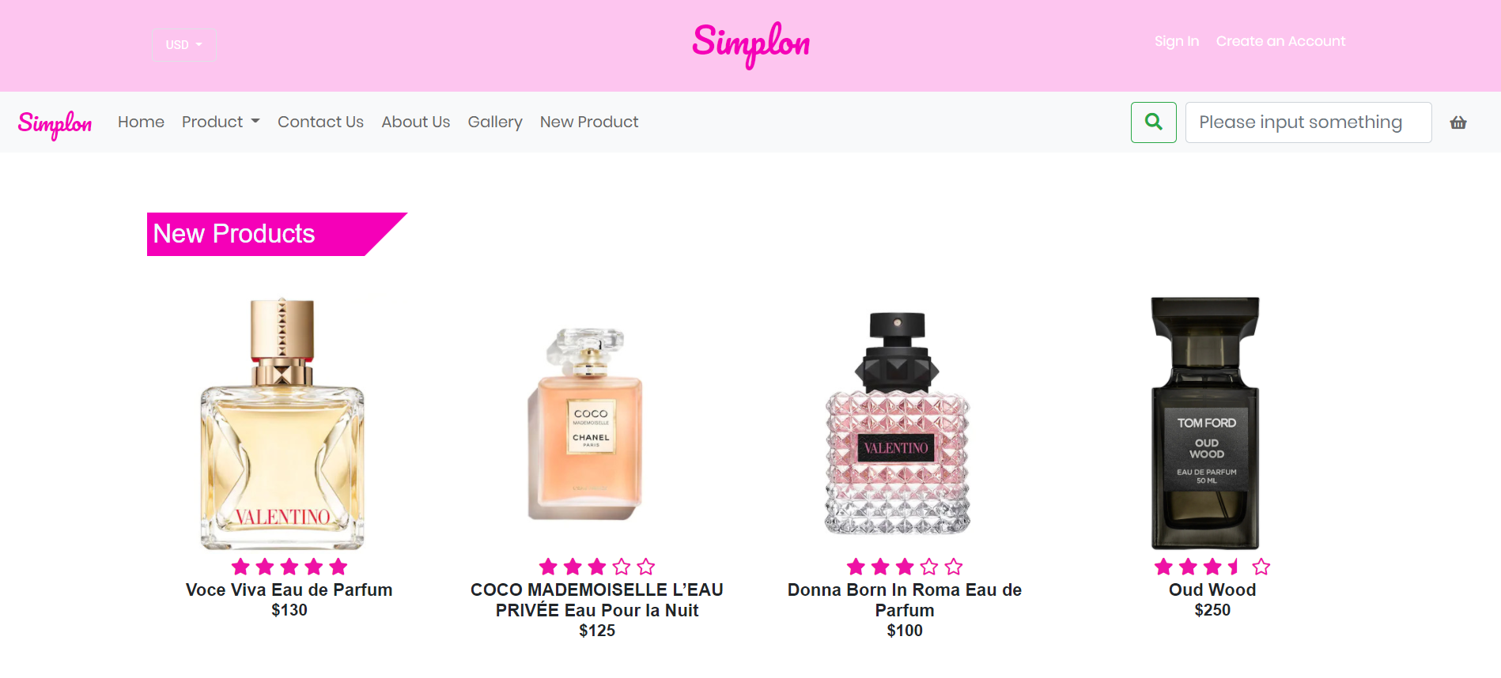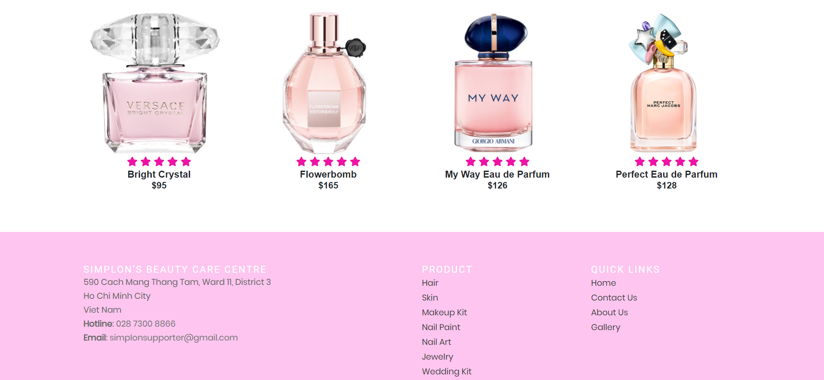

## 5. Account page

a. *Description*

This page includes two options for customers who want to log in or sign up an account.

b. *Screenshot*

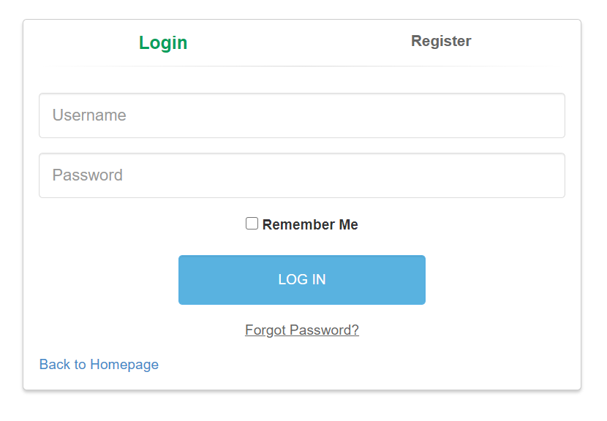

# TASK SHEET REVIEW 2

|  |  |  |  |  |  |  |  |
| --- | --- | --- | --- | --- | --- | --- | --- |
| **Project Ref. No.:**  **eP/Advertisement** **Portal Management** **System/01** | | **Project Title:** | **Activity Plan** **Prepared** **By:** | **Date of Preparation of Activity Plan:** | | | |
| **Sr.No.** | **Task** | **Actual Start** **Date** | **Actual** **Days** | **Team** **Mate** **Names** | **Status** |
| 1 | Design and coding Homepage | Beauty Care | All members | 16/10/2020 | 1 |  | Completed |
| 2 | Design and coding Product page (include hair, skin, makeup kit, nail paint, nail art, jewelry, wedding kit) | 20/10/2020 | 1 |  | Completed |
| 3 | Design and coding Contact us, about us | 22/10/2020 | 1 |  | Completed |
| 4 | Design and coding Gallery, new product | 24/10/2020 | 1 | All members | Completed |
| 5 | Group pages together with links and update information | 28/10/2020 | 1 |  | Completed |
| 6 | Test website in different browsers | 02/10/2020 | 1 |  | Completed |

|  |  |
| --- | --- |
| Date: | |
| Signature of Instructor  **Ms. Pham Thi Lanh** | Signature of Team Leader  **Do Dinh Dai** |

# 